**EXPERIMENT 1**

**Lab Exercise: Introduction to Vagrant and Vagrantfile**

This exercise will guide them through setting up a virtual environment using Vagrant, configuring the environment via a Vagrantfile, and managing the virtual machines (VMs) with basic Vagrant commands.

**Objective:**

* Learn how to set up and configure virtual environments using Vagrant.
* Understand the structure and components of a Vagrantfile.
* Gain hands-on experience in managing virtual machines using Vagrant commands.

**Prerequisites:**

* Basic knowledge of virtualization concepts.
* Familiarity with command-line interfaces.
* Installation of Vagrant and VirtualBox (or any other supported provider) on your local machine.

**Step-by-Step Exercise:**

**1. Setting Up the Environment:**

**Install Vagrant:**

* Download and install Vagrant from the official website.
* Ensure you have VirtualBox installed as it is a commonly used provider with Vagrant.
* Verify Installation:
* Open a terminal or command prompt.
* Run the following commands to verify the installation:

vagrant –version

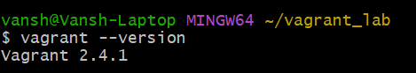

**2. Creating a New Vagrant Project:**

* Create a Project Directory:
* In your terminal, create a new directory for your Vagrant project and navigate into it:

mkdir vagrant_lab

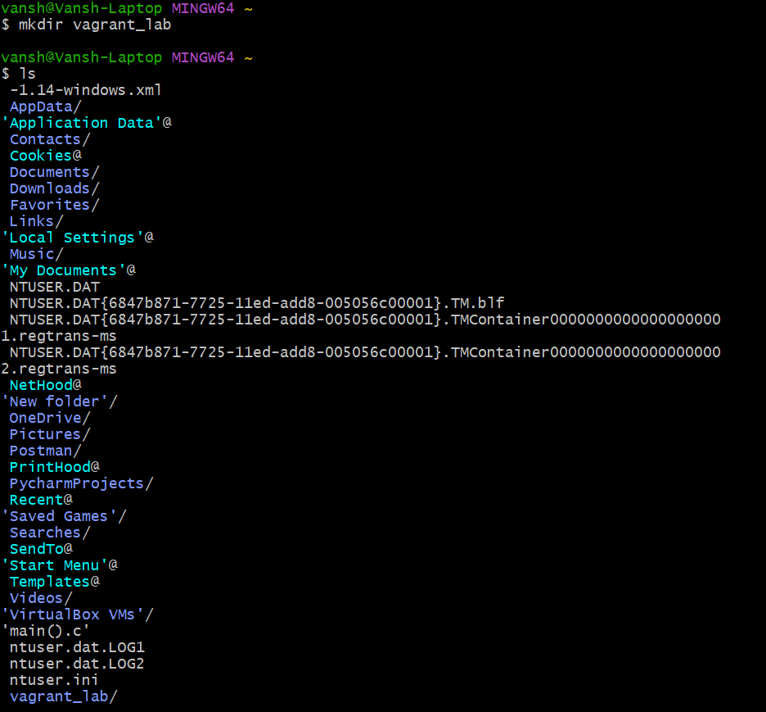

cd vagrant_lab

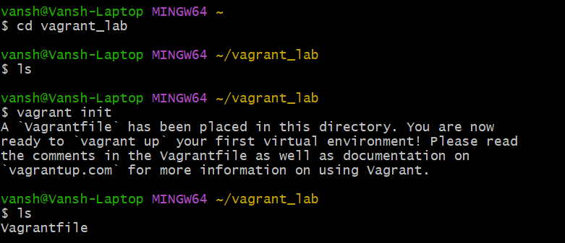

**Initialize Vagrant:**

* Run the following command to initialize a new Vagrantfile in your project directory:

vagrant init

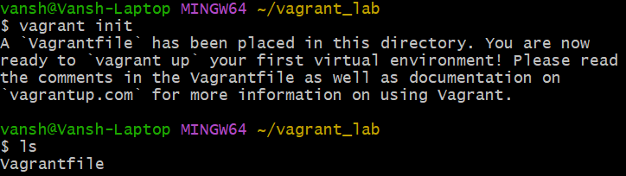

This command will generate a Vagrantfile in the current directory.

**3. Understanding the Vagrantfile:**

* Open the Vagrantfile:
* Open the Vagrantfile in a text editor of your choice.
* The Vagrantfile is a Ruby-based configuration file used to define the virtual environment.
* Basic Vagrantfile Configuration:
* Modify the Vagrantfile to configure a basic virtual machine. For example:

Vagrant.configure("2") do |config|

config.vm.box = "ubuntu/bionic64" # Specifies the base box to use (Ubuntu 18.04)

config.vm.network "private_network", type: "dhcp" # Configures a private network

config.vm.provider "virtualbox" do |vb|

vb.memory = "1024" # Allocates 1GB of RAM to the VM

end

end

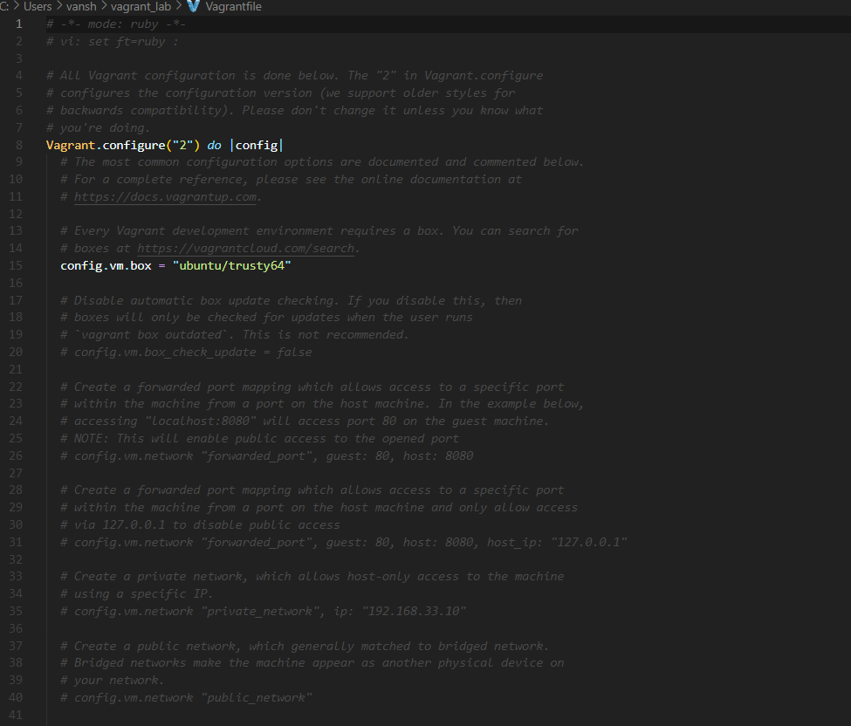

**4. Launching and Managing the VM:**

Start the VM:

In the terminal, start the VM using the following command:

vagrant up

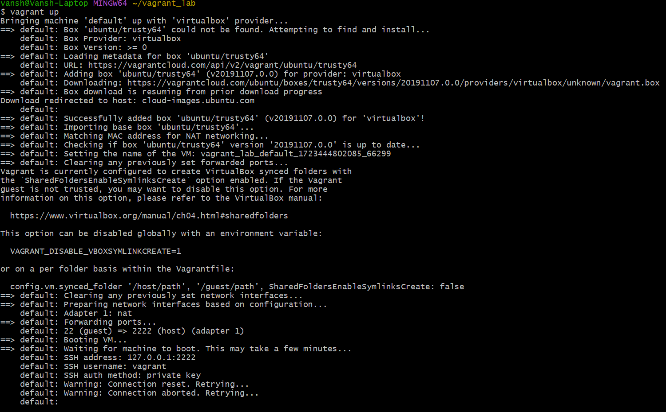

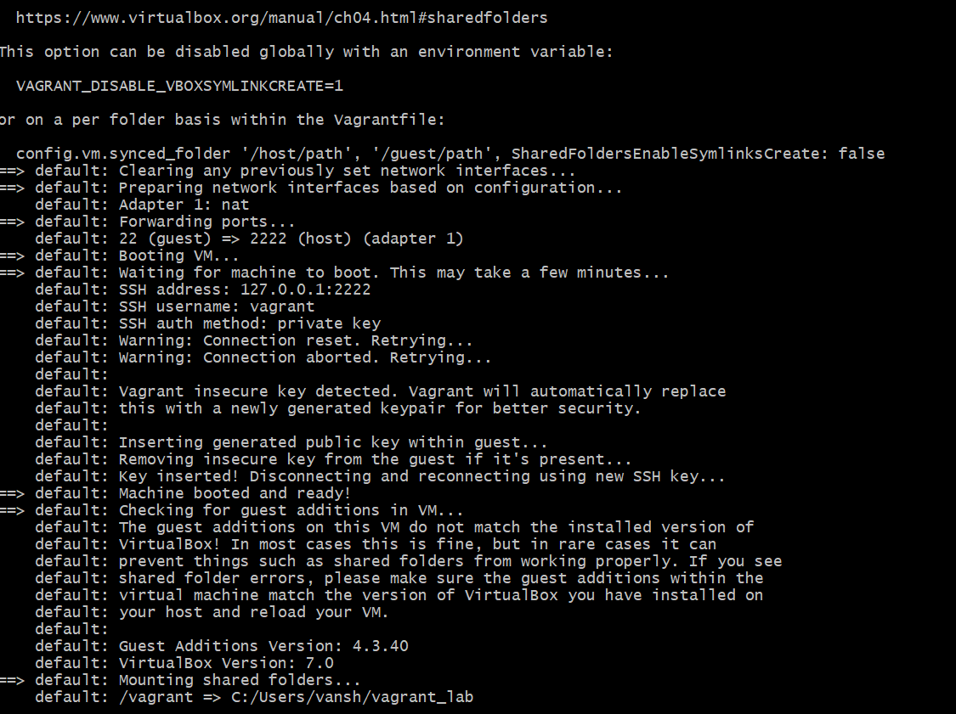

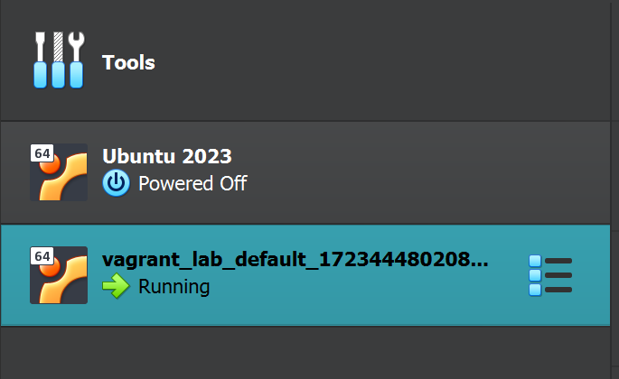

Vagrant will download the specified box (if not already downloaded) and launch the VM.

* SSH into the VM:
* Connect to the running VM using SSH:

vagrant ssh

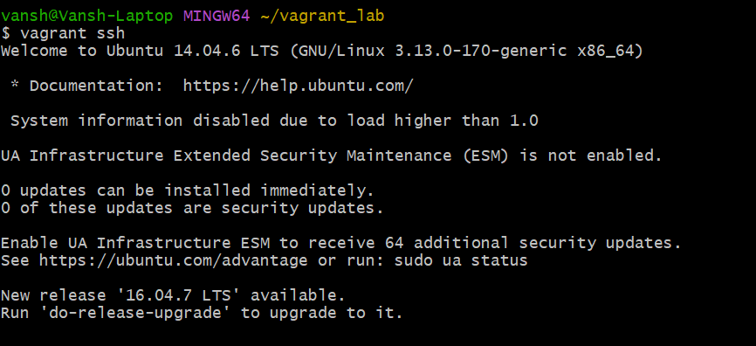

* This command will log you into the VM’s shell.
* Exploring the VM:
* Inside the VM, explore the filesystem, install packages, and run commands to understand the environment.
* Stop the VM:
* Exit the SSH session by typing exit.
* Stop the VM with the following command:

vagrant halt

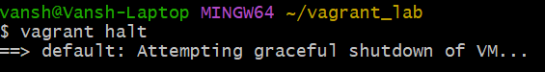

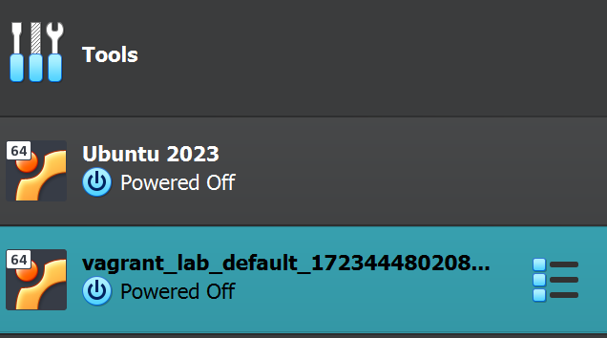

Destroy the VM (optional):

To remove the VM completely, use the following command:

vagrant destroy

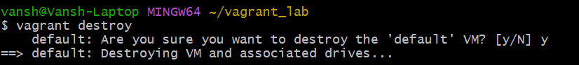

This will remove all traces of the VM, including any data stored on it.

Explore the benefits of using Vagrant for development and testing environments.

This lab exercise provides a hands-on introduction to Vagrant, focusing on creating and managing virtual environments through a Vagrantfile. It offers both foundational learning and opportunities to explore more advanced features.